## Document management

|  |  |  |  |
| --- | --- | --- | --- |
| **Version** | **Date** | **Author** | **Comments** |
|  |  |  |  |
|  |  |  |  |
|  |  |  |  |
|  |  |  |  |

## Control information

|  |  |
| --- | --- |
|  |  |
|  |  |
|  |  |
|  |  |
|  |  |

Table of contents:

Document management 1

Control information 1

Table of contents: 1

Description 3

Use cases 3

Case 1: Cancel purchase orders not received in the defined interval 3

Functional specifications 4

Abbreviations 4

Changes of existing functionalities 4

Changes of the Procurement and sourcing parameters 4

Changes of the Purchase order header form 5

New functionalities 5

Canceling orders batch 5

Dependencies and assumptions 7

Issue list 7

Approvals 7

## Description

Confirmed purchase orders not receipt in a defined number of days should be automatically canceled.

## Use cases

### Case 1: Cancel purchase orders not received in the defined interval

1. Navigate to Procurement and sourcing -> Setup -> Procurement and sourcing parameters
2. In Period of validity specify the number of days
3. Navigate to Procurement and sourcing -> Setup -> Purchase orders -> Cancel order batch
4. Specify the recurrence and run the batch
5. Navigate to Procurement and sourcing -> Common -> All purchase orders
6. Create a new purchase order
7. Specify the delivery date. Period of validity in purchase order header should inherit the value from parameters. ***Note: the field is editable***
8. When the batch is processed, the quantities with receipt status On order from the orders not delivered in the specified interval will be canceled.

## Functional specifications

### Abbreviations

N/A

### Changes of existing functionalities

#### Changes of the Procurement and sourcing parameters

On Procurement and sourcing parameters a new fields should be added

|  |  |  |  |
| --- | --- | --- | --- |
| **Field name (EN-US & EN-GB)** | **Type** | **Position** | **Details** |
| **Period of valability Perioada de valabilitate** | Extends SalesValidDays | Default values group |  |

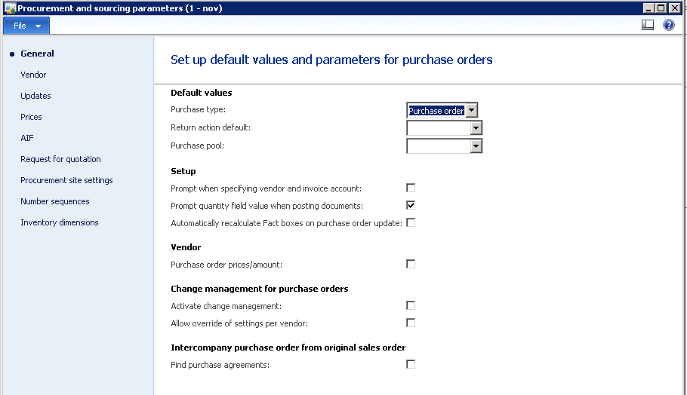

#### Changes of the Purchase order header form

On Purchase order header a new fields should be added

|  |  |  |  |
| --- | --- | --- | --- |
| **Field name (EN-US & EN-GB)** | **Type** | **Position** | **Details** |
| **Period of valability Perioada de valabilitate** | Extends SalesValidDays | Delivery fast tab, delivery group | The value from Procurement and sourcing parameters will be inherited. The field is editable. |

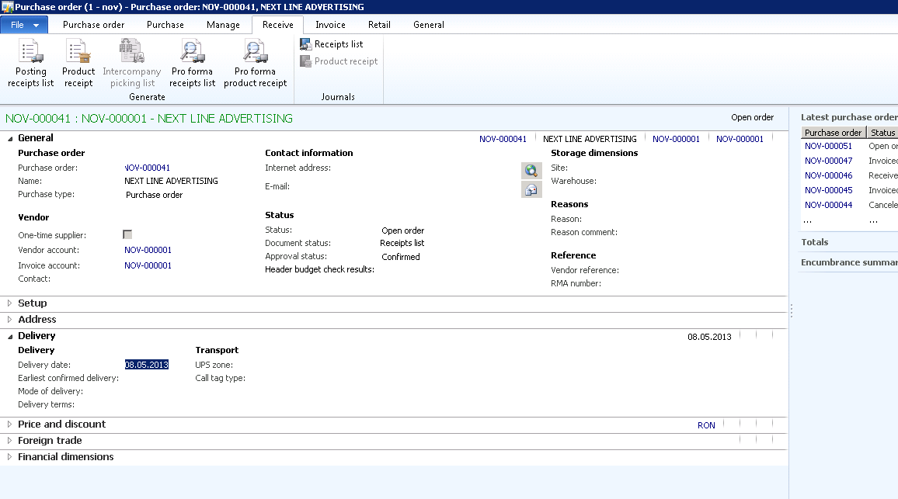

### New functionalities

#### Canceling orders batch

A new batch for recursive processing will be developed.

|  |  |  |  |
| --- | --- | --- | --- |
| **Batch name (EN-US & EN-GB)** | **Type** | **Position** | **Details** |
| **Cancel order batch Batch anulare comenzi** | N/A | Procurement and sourcing -> Setup -> Purchase orders |  |

The batch will calculate the difference between current date and order delivery date, and from the result substract the Period of validity from purchase order. If the result is positive the order should be canceled using standard cancel functionality All Purchase orders -> Purchase order tab -> Cancel (Maintain group). ***Note: Only orders with approval status “Confirmed” and order status “Open order” should be canceled.***

## Dependencies and assumptions

|  |  |
| --- | --- |
| **Description** | **Type (assumption/dependency)** |
|  |  |
|  |  |

## Issue list

|  |  |  |  |  |  |
| --- | --- | --- | --- | --- | --- |
| **Nr.** | **Issue description** | **Found by** | Resolution | Proposed by | **Status** |
|  |  |  |  |  |  |
|  |  |  |  |  |  |
|  |  |  |  |  |  |

## Approvals

|  |  |
| --- | --- |
| **Vendor** | **Customer** |
| Project manager: | Project manager: |